Judgment by Algorithm: Exploring AI Fairness in Criminal Justice - Synthetic Data Analysis

Group: Paine’s Protectors (SF RAI - Civil Rights Groups)

**Summary**

For this project, we focus on evaluating the use of AI in criminal justice, with an emphasis on analyzing AI and human bias and fairness across three racial groups (predominantly black, predominantly white, and racially balanced which is annotated as others) and three counties (Claiborne, Copiah, and Warren).

1. **Demographic Distribution**

Figure 1.1.1. Sample Racial Composition by County

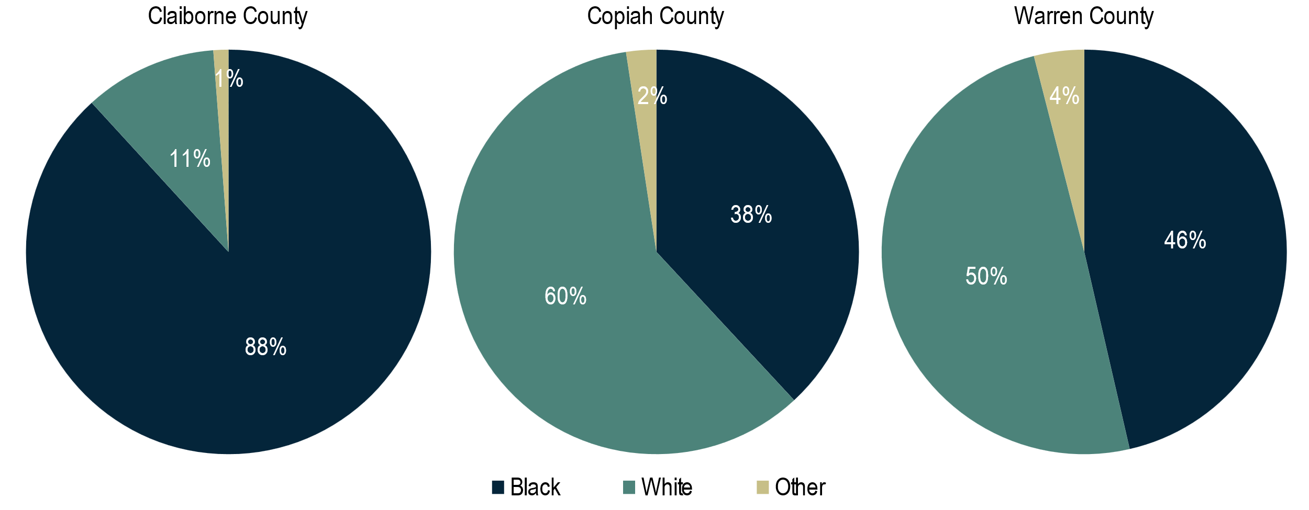

Figure 1.1.2. Sample Population by Race and County

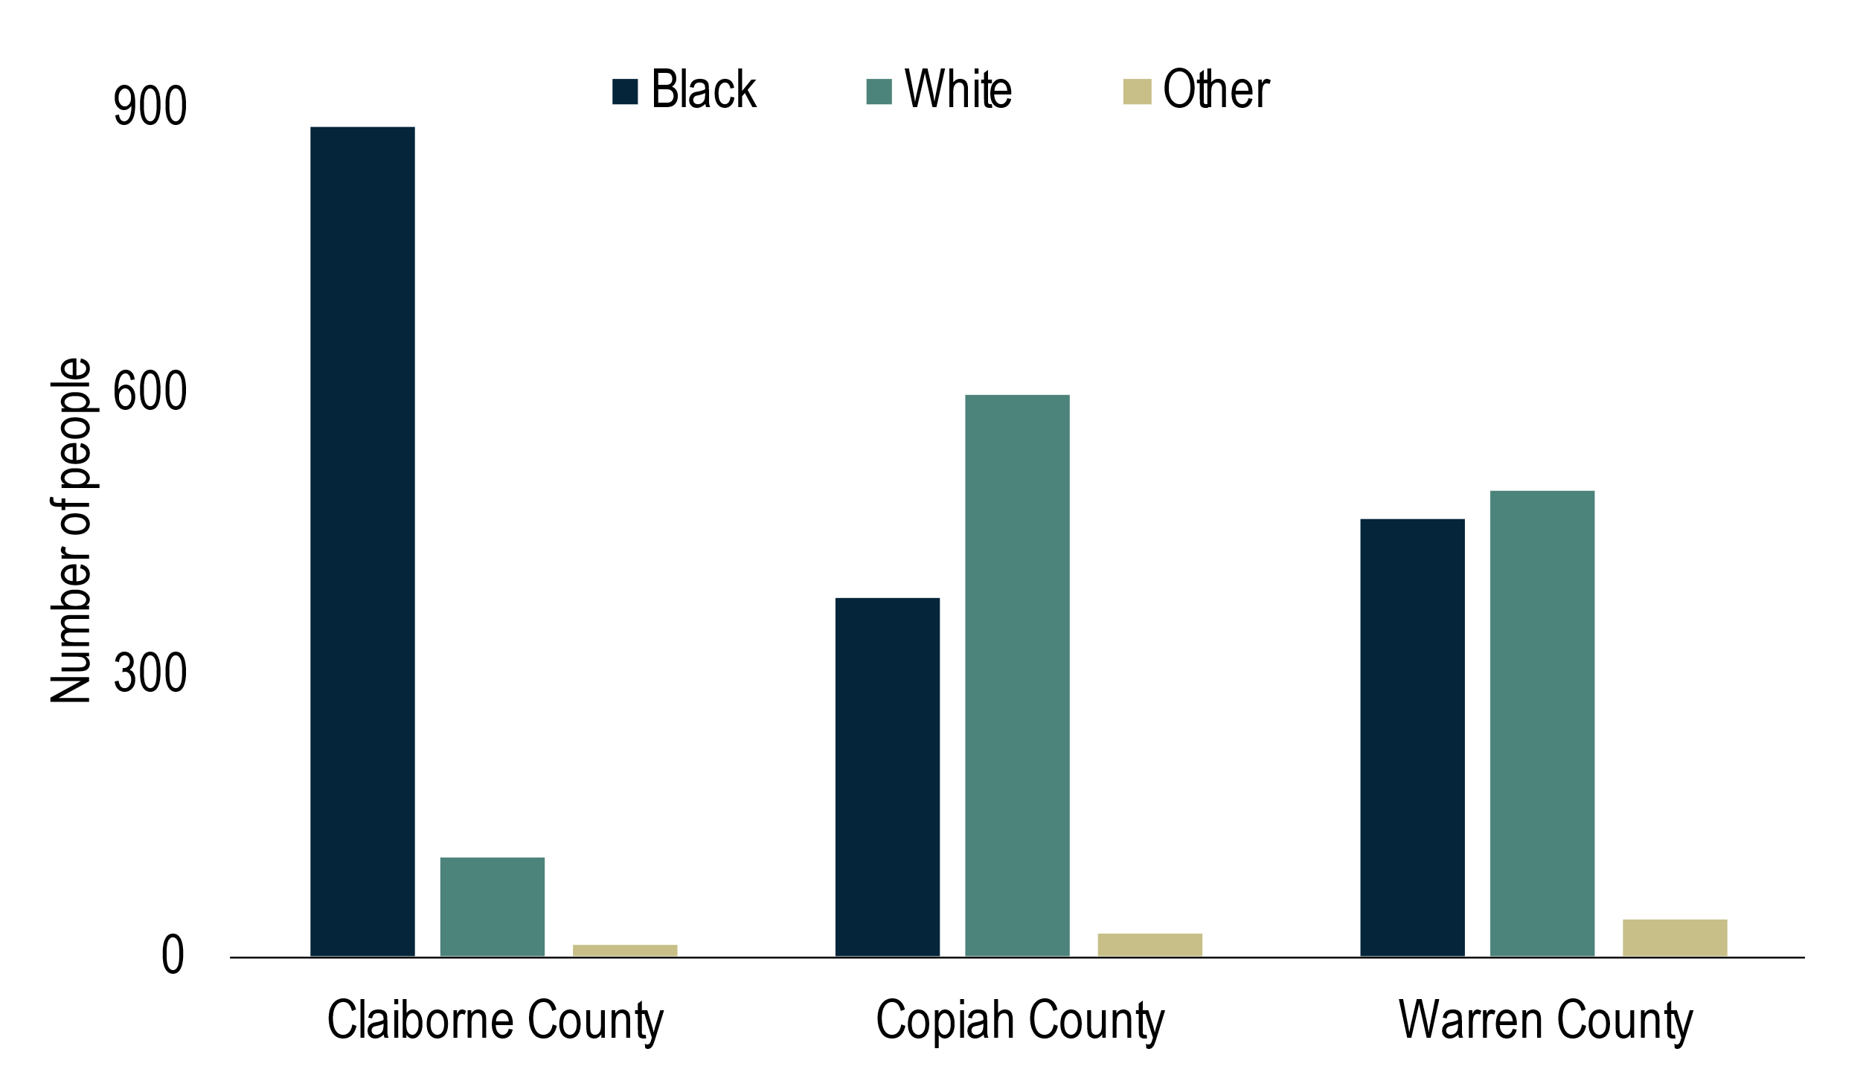

Table 1.1.1. Sample Population by Race and County

| **County** | **Black** | **White** | **Other** | **Total** |
| --- | --- | --- | --- | --- |
| Claiborne County | 882 | 106 | 12 | 1000 |
| Copiah County | 381 | 595 | 24 | 1000 |
| Warren County | 464 | 496 | 40 | 1000 |
| **Total** | 1727 | 1197 | 76 | 3000 |

The total sample population of the datasets across 3 counties is balanced, each containing 1000 observations (Table 1.1.1). There are noticeable disparities in the racial composition, both in the overall population and across the 3 counties. Black defendants make up the majority of the sample population (57.6%), followed by White defendants (39.9%%) and others (2.5%). Claiborne county has a significantly larger black population, representing about 88% of the county total (Figure 1.1.1) and over half of the total black population for all 3 counties (Table 1.1.1, Figure 1.1.2). Due to the disparate racial distribution, the conclusions drawn from these datasets may be vulnerable to statistical bias, especially for Others whose data is very scarce.

Figure 1.2.1. Sample Gender Composition by County

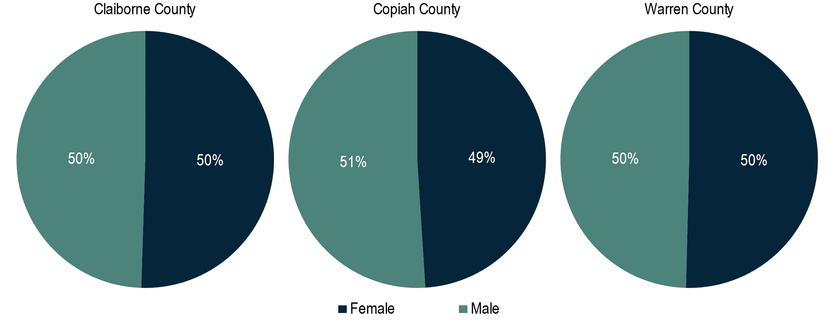

Figure 1.2.2. Sample Population by Gender and County

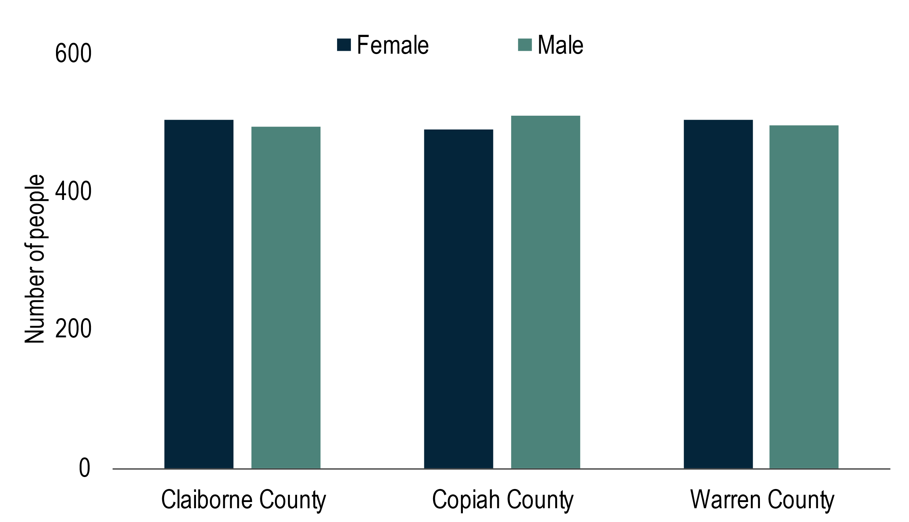

Figure 1.3.1. Sample Education Level Composition by County

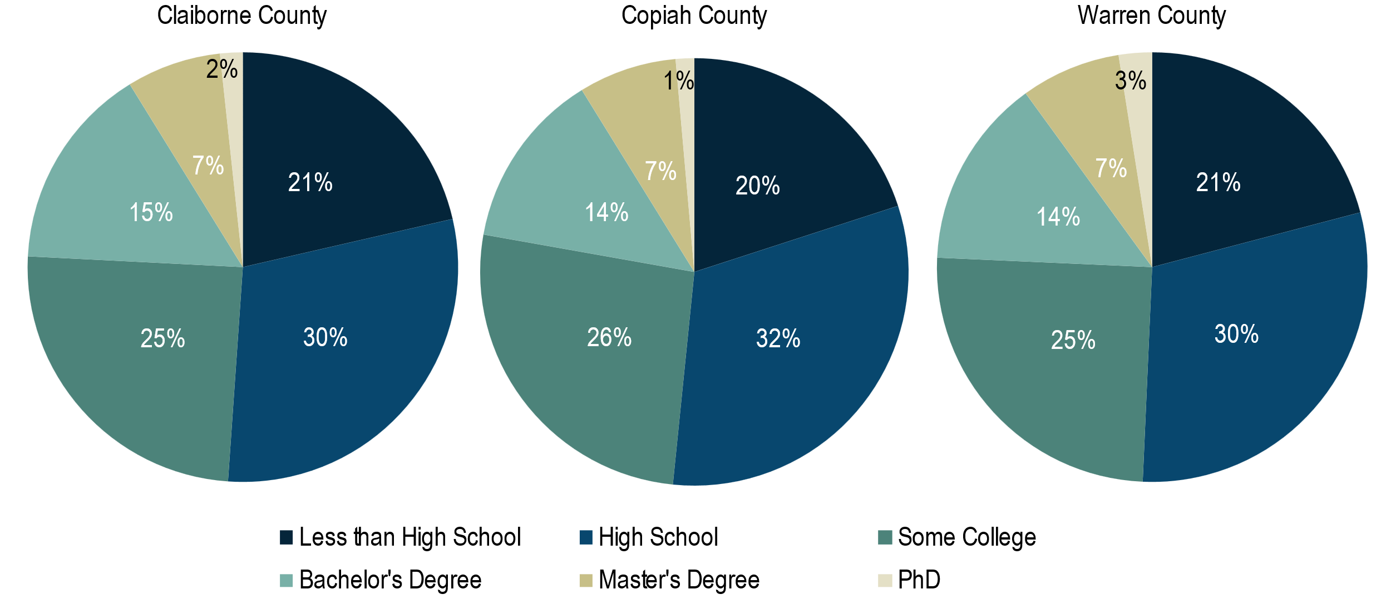

Figure 1.3.2. Sample Population by Education Level and County

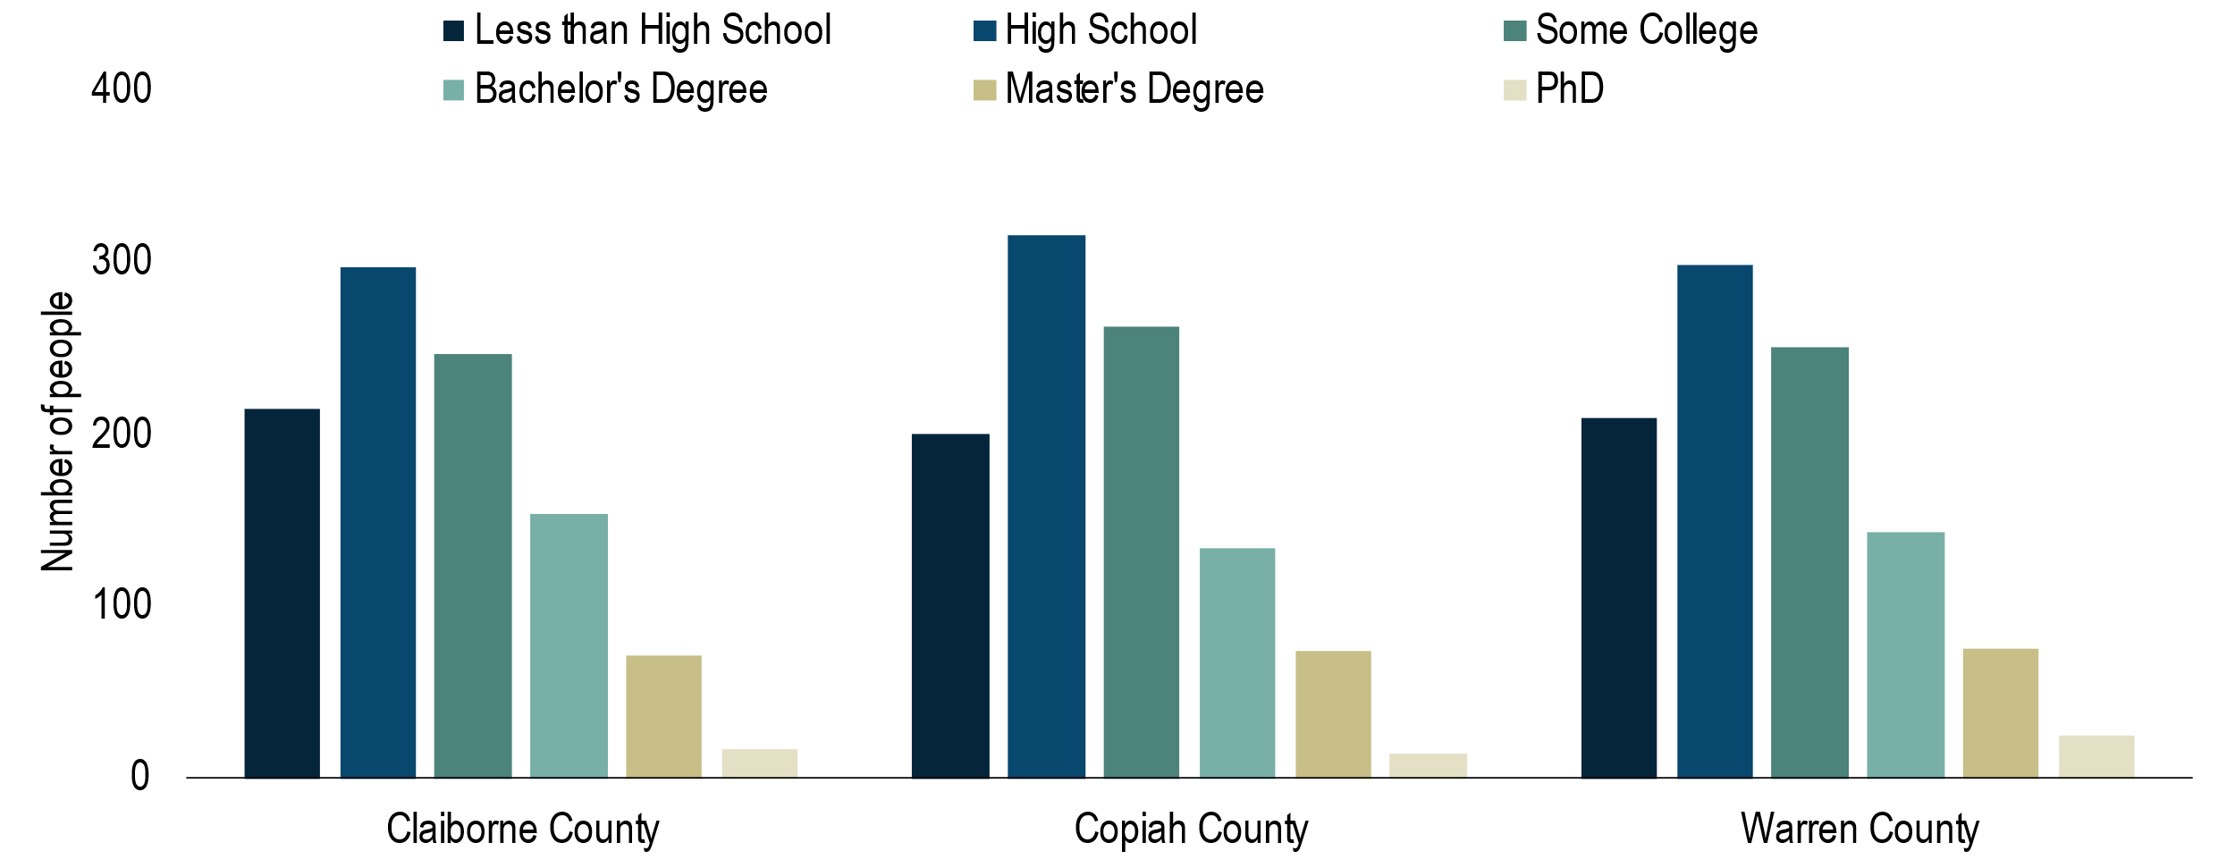

Female and Male populations are almost equally distributed both in the overall population and across the 3 counties. As for education, individuals whose highest level of education is High School has the highest number, followed by Some College and Less than High School. Individuals with more advanced degrees only consist of less than 25% of the population. This trend is consistent across all 3 counties.

1. **Risk scores among different demographic groups**

Figure 2.1. Average Risk Score by Race and County

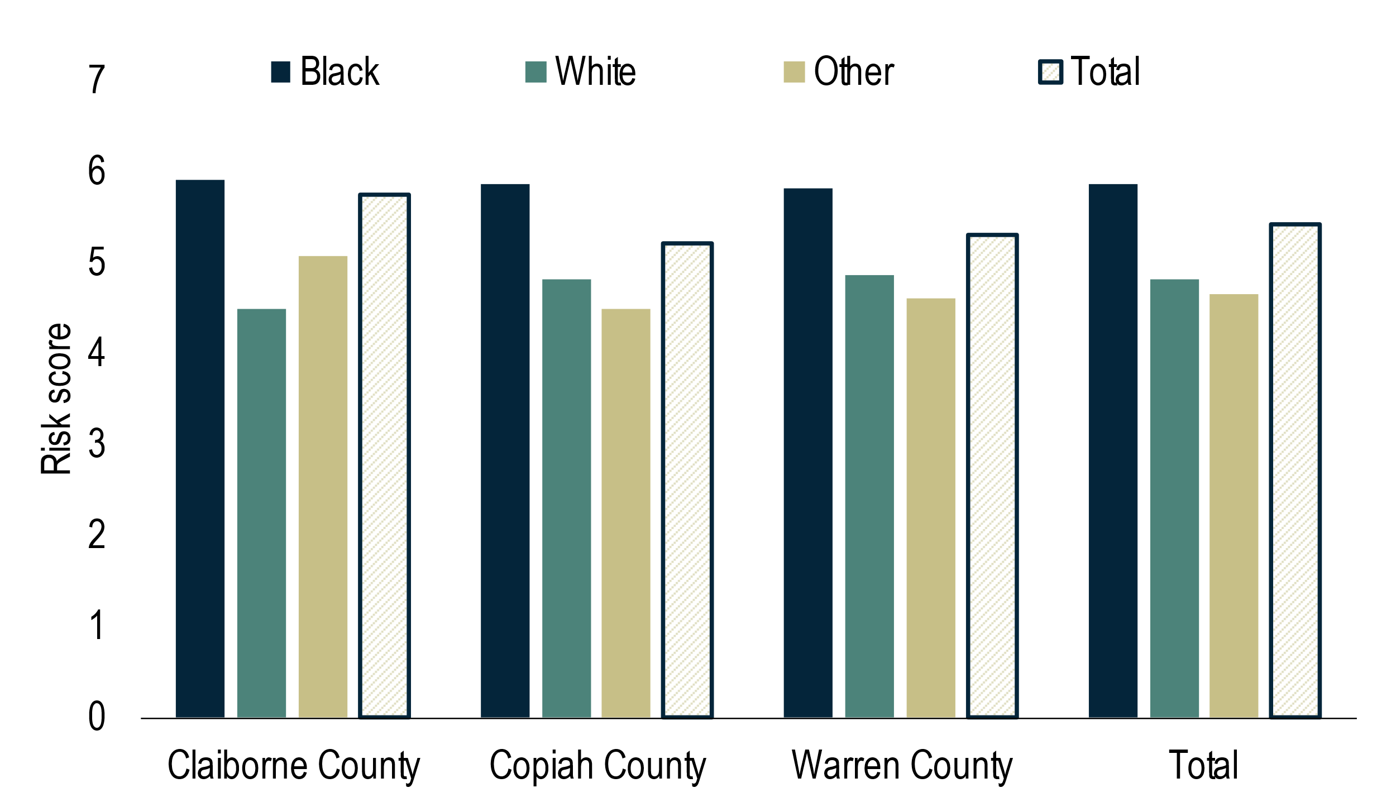

Table 2.1. Difference with Average Risk Score of Total Population

| **County** | **Black** | **White** | **Other** |
| --- | --- | --- | --- |
| Claiborne County | +0.16 | -1.25 | -0.67 |
| Copiah County | +0.65 | -0.39 | -0.71 |
| Warren County | +0.51 | -0.42 | -0.68 |
| **Total** | +0.45 | -0.60 | -0.77 |

Figure 2.2. Average Risk Score by Gender and County

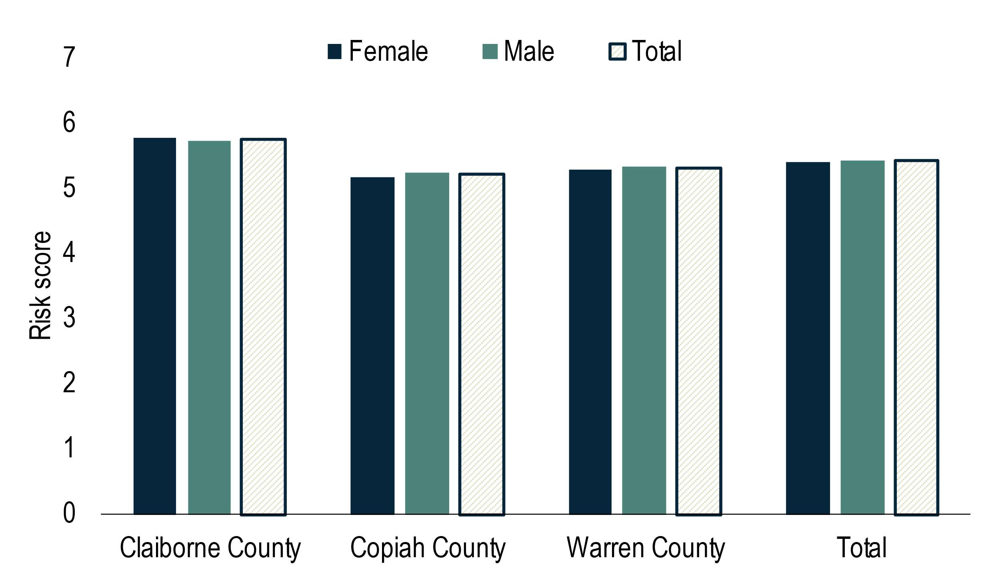

Overall, the average risk score derived by AI is higher for individuals in Claiborne county than those in the other 2 counties. Among different racial groups, risk scores are on average higher for Black individuals than for White and Other individuals by at least 1. This trend is consistent across all 3 counties. In Claiborne county with the highest density of Black individuals, the racial disparity is more significant, where the average risk score for Black is the highest and that for White is the lowest among the 3 counties. Individuals categorized as Other have the lowest risk score on average, but have slightly higher average score than White in Claiborne county. However, due to the small sample size of Other, nuanced differences may not be significant and cannot generalize the larger racial group. In contrast, the average risk scores are well balanced and present little differences among Female and Male groups.

1. **Risk score and judge’s decision on bails among different demographic groups**

Figure 3.1.1. Risk Score Distribution by Judge’s Bail Decision and Race, Size of Population

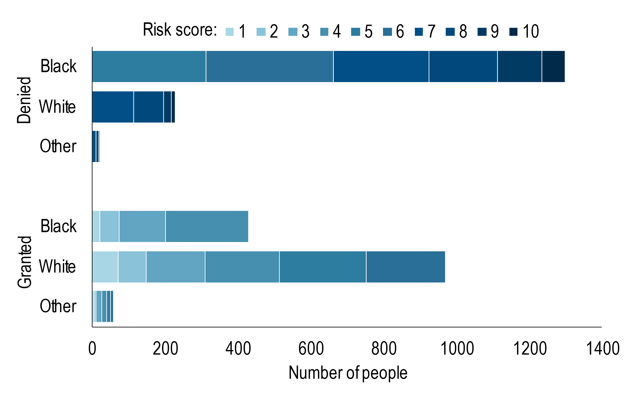

Figure 3.1.2. Risk Score Distribution by Judge’s Bail Decision and Race, Share of Population

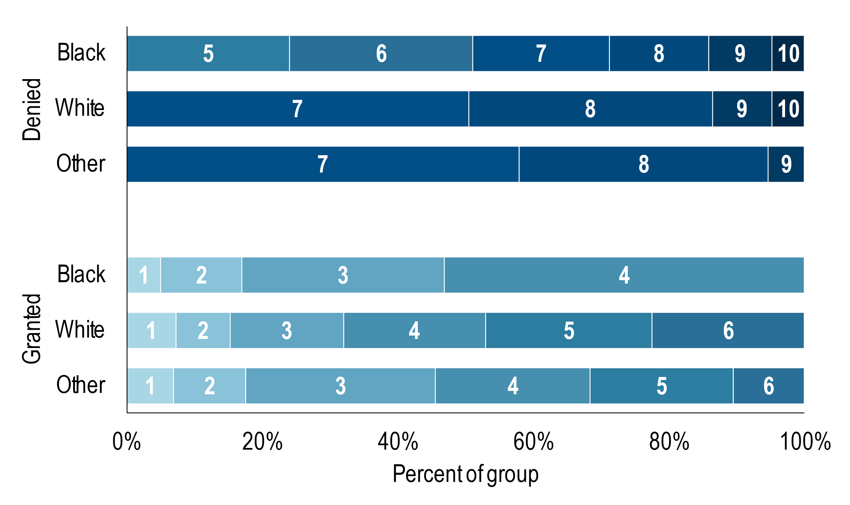

Figure 3.2.1. Risk Score Distribution by Judge’s Bail Decision and Gender, Size of Population

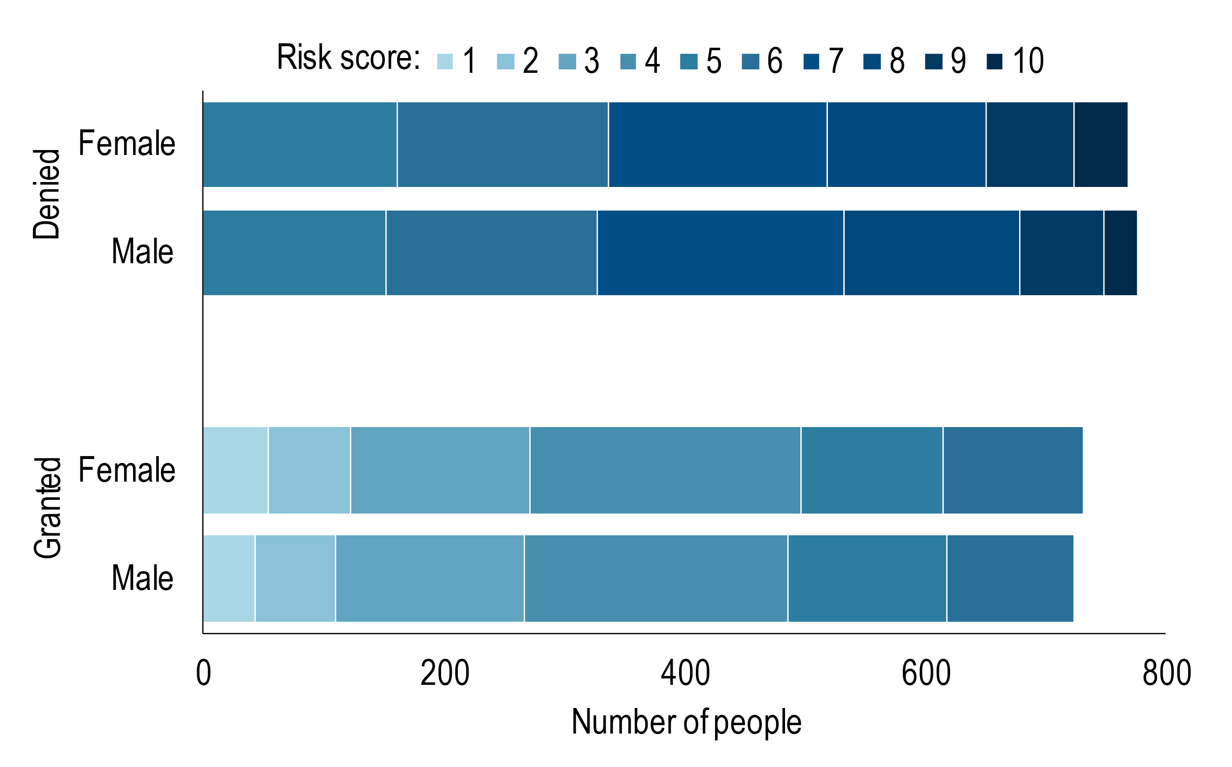

Figure 3.2.2. Risk Score Distribution by Judge’s Bail Decision and Gender, Share of Population

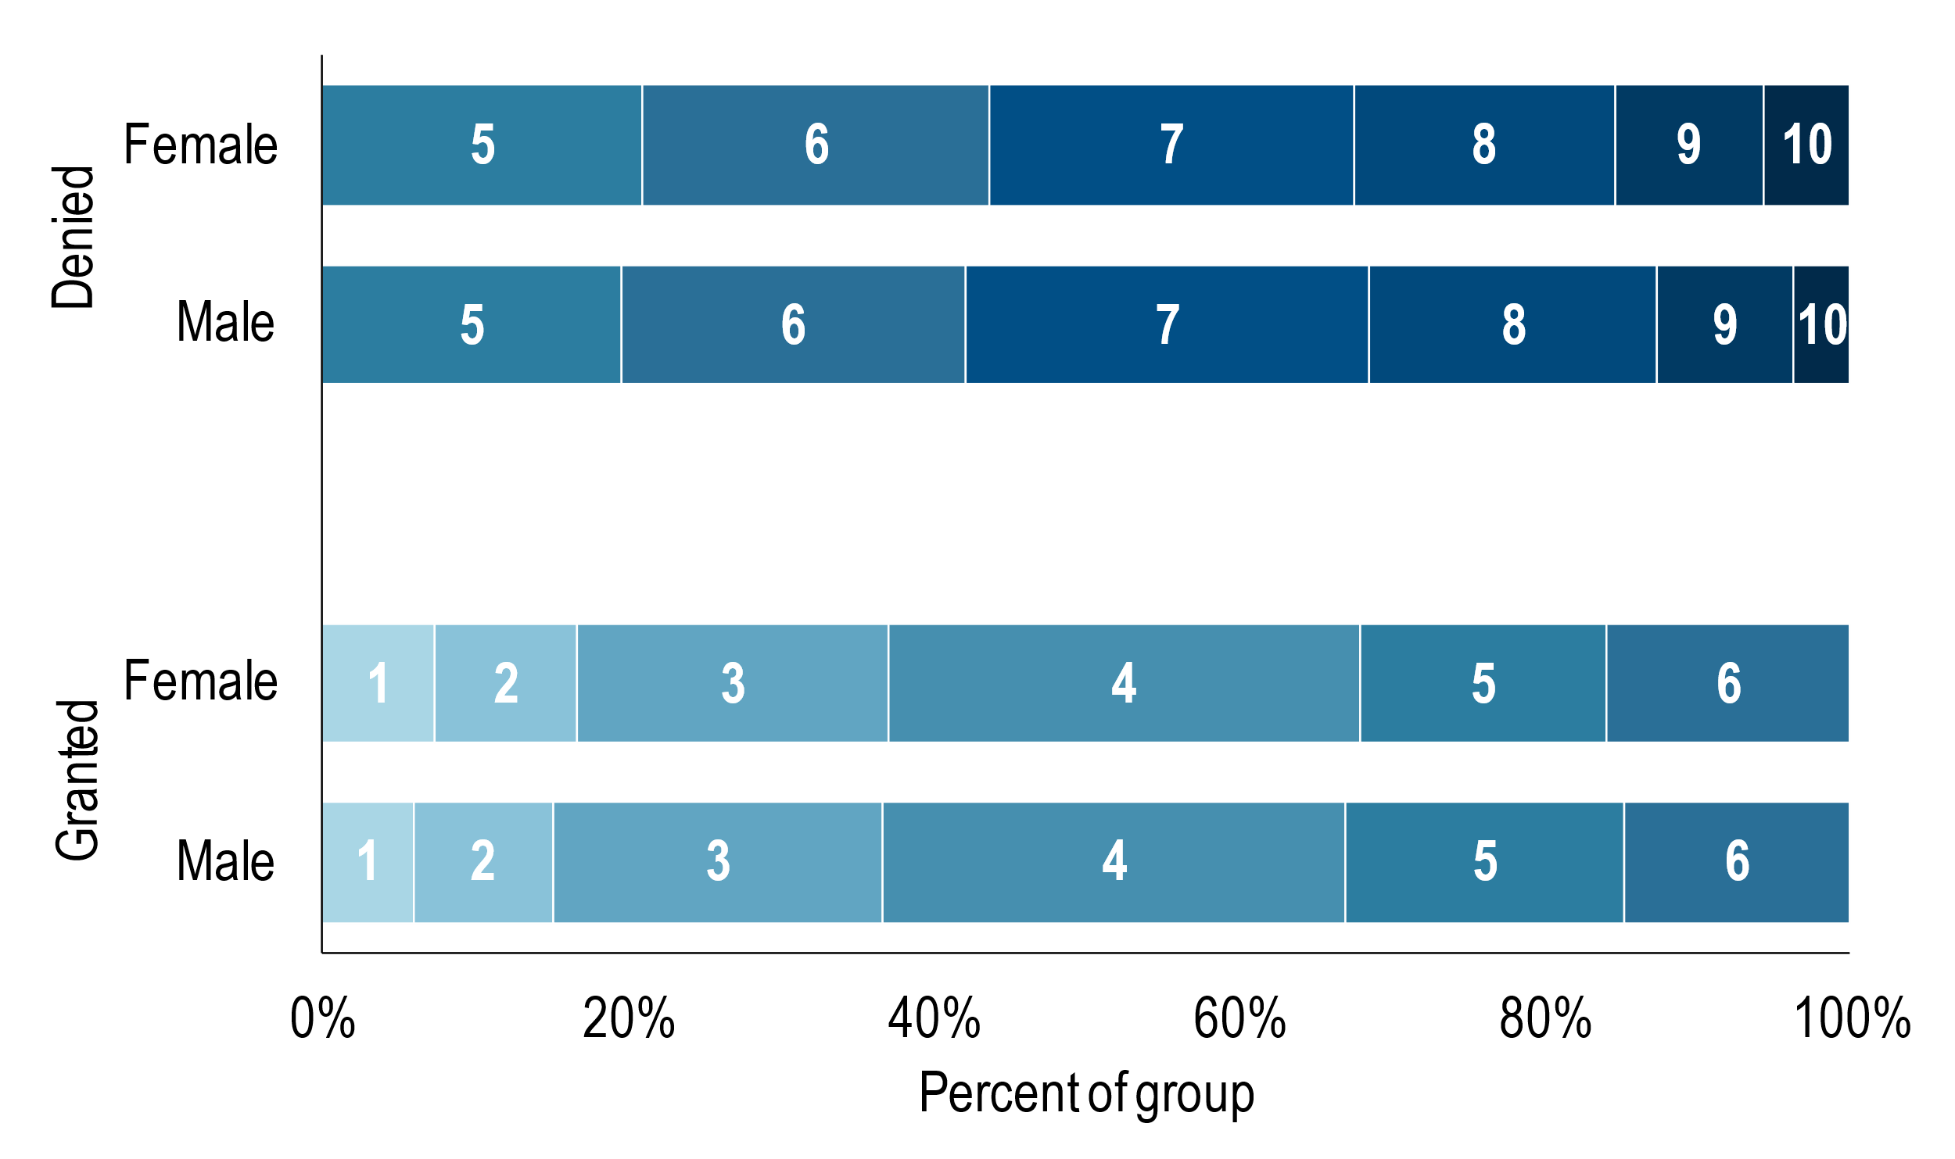

Among the group who were denied bail, there were far more Black individuals than White or Other, whereas most individuals granted bail were White. Black individuals given a risk score of 5 or higher were more likely to be denied bail by the judge. White or Other individuals were much more likely to be granted bail than Black individuals, however, since people who were White or Other and were granted bail had risk scores of up to 6. When comparing gender groups who were denied or granted bail, however, no major differences were evident. The proportion of risk-score groups were generally similar across males and females who were denied or granted bail.

1. **Re-offense rate and fairness metrics among different racial groups**

Figure 4.1. Re-offense, False Positive, and False Negative Rates by Race

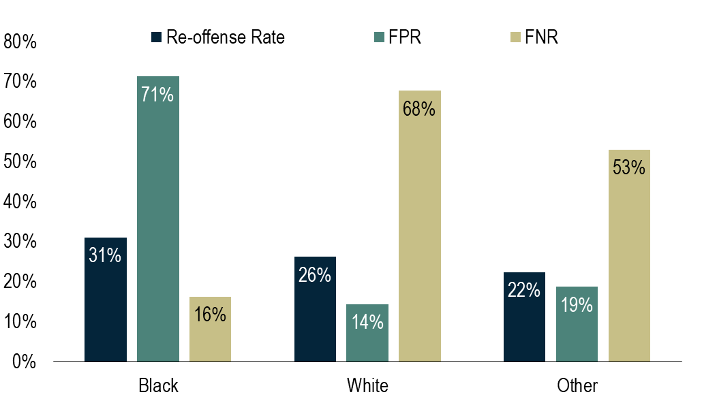

Table 4.1. Fairness Metrics

| **Race** | **Judge Decision** | **Re-offended** | **Did Not Re-offend** |
| --- | --- | --- | --- |
| Black | Denied | 449 | **849** |
| Granted | 87 | 342 |
|  |  |  |  |
| White | Denied | 101 | **127** |
| Granted | 212 | 757 |
|  |  |  |  |
| Other | Denied | 8 | **11** |
| Granted | 9 | 48 |

The reoffense rate was not found to be very different across racial groups, but the false positive rates (FPR) and false negative rates (FNR) do differ significantly. The FPR for White individuals was over 4 times higher than Black individuals. The FNR for Black individuals was over 5 times higher than White individuals.

**Appendix.**

Figure 3.1.1.alt. Risk Score Distribution by County, Judge’s Bail Decision, and Race,  
 Size of Population

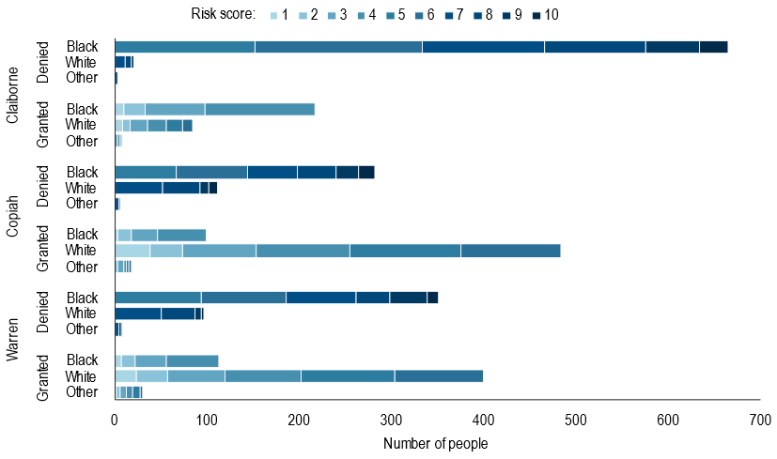

Figure 3.1.2.alt. Risk Score Distribution by County, Judge’s Bail Decision and Race,  
 Share of Population

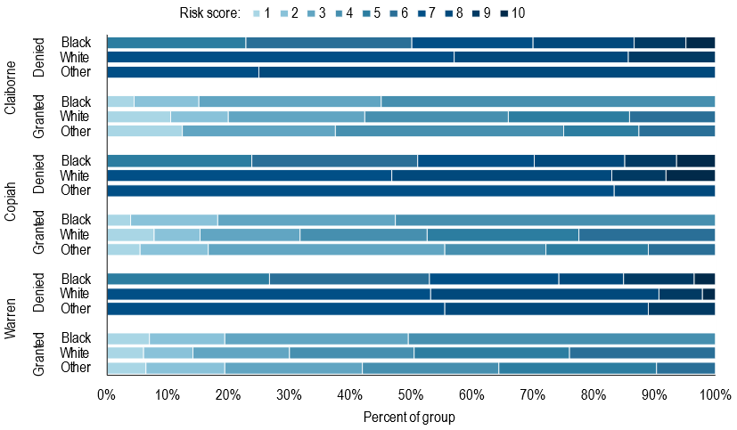

Figure 3.2.1.alt. Risk Score Distribution by County, Judge’s Bail Decision, and Gender,  
 Size of Population

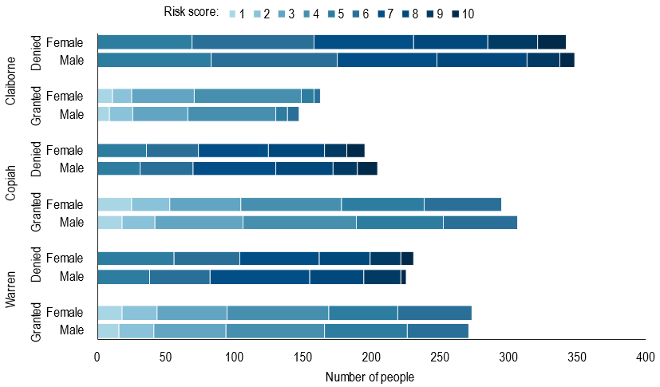

Figure 3.2.2.alt. Risk Score Distribution by County, Judge’s Bail Decision and Gender,  
 Share of Population

